Survival
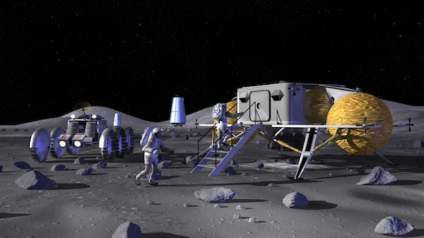
Core Values Activity: Picking from a list
Instructions to Team:
The year is 2025 and you and three other crew members are traveling to the Moon. You land off course. The only way you will survive is by making it to the outpost (80km away) that has already been established on the Moon.
Here are some facts you know: (Source: quoted from NASA activity document, see link below)
- The Moon has no atmosphere or magnetosphere to protect you from space radiation.
- The regolith, or lunar soil, is a mixture of materials that includes sharp, glassy particles.
- The gravity field on the Moon is only one-sixth as strong as Earth’s.
- More than 80 percent of the Moon is made up of heavily cratered highlands.
- Temperatures vary widely on the Moon. It can be as cold as -193°C (-315°F) at night at its poles and as hot as 111°C (232°F) during the day at its equator.
In five minutes, pick 5 items from the list provided that you think are the most important to your survival until you either reach the outpost or are rescued by people in the outpost.

life raft | 38 litres of water | map of the Moon’s surface
two 45.5kg tanks of oxygen | first aid kit | 15 meters of nylon rope
space blanket | food concentrate | parachute
lights with solar-powered rechargeable batteries | magnetic compass | space suit repair kit
signal mirror | solar-powered radio receiver-transmitter | box of matches

